**Maintenance method for string dropping of extreme air protection board**

Fault type: dropped string

Tools used: screwdriver, multimeter, tweezers, soldering iron

Model：JK-BD6A24S6P

Ver.：V11.1.1

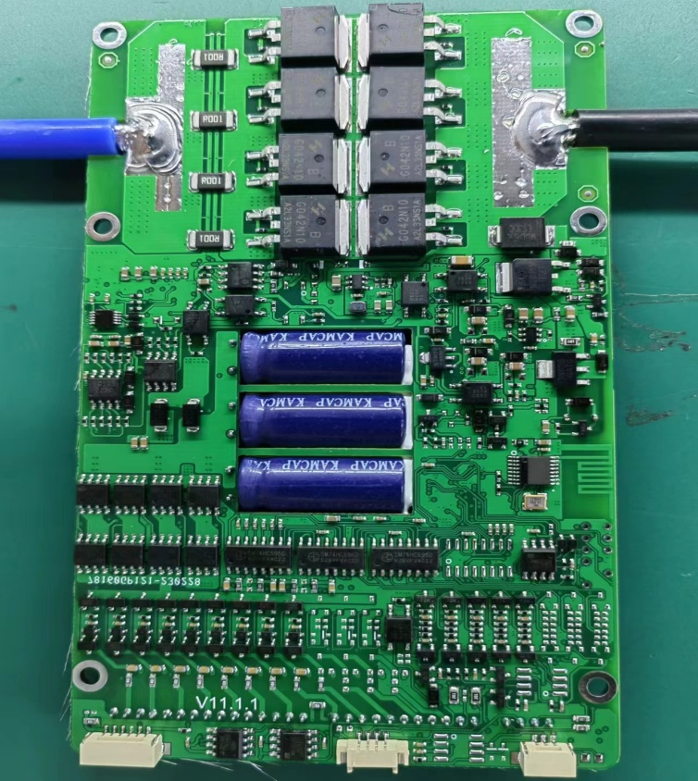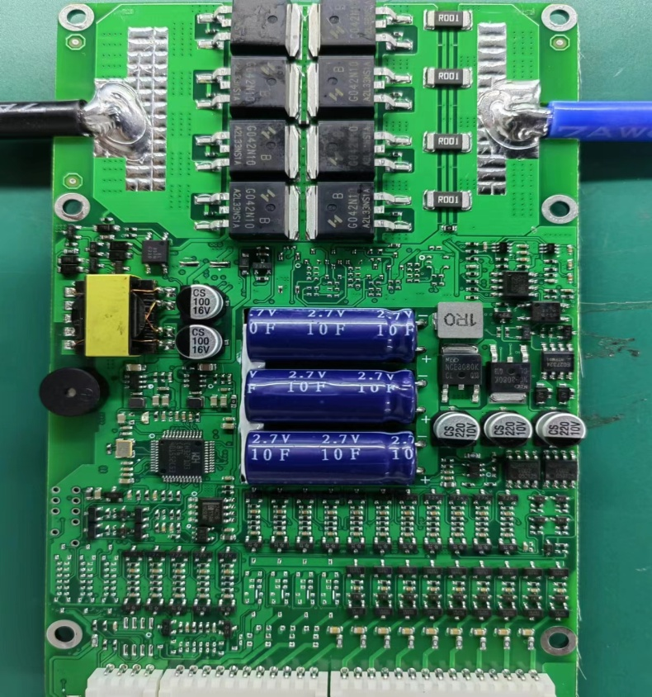

**反面**

**正面**

图8

图7

图4

图5

图6

图3

图2

图1

**Repair steps**

**1. Use a multimeter to test the R01 fuse resistance in the on/off or resistance range (positions 1 and 2 in Figure 1). Under normal circumstances, there is a resistance value of 0.1 ohms. If there is no resistance value, the resistor needs to be replaced.**

**2. Use a multimeter diode range to test the voltage drop of pin 0103 MOS transistor (positions 3 and 4). Under normal circumstances, the MOS transistor has a voltage drop of about 0.49V. If the voltage drop is 0 or there is a large difference in voltage drop, the MOS transistor will break down and be damaged. The MOS transistor needs to be replaced. Note: The red probe of the multimeter is connected to 2 pins, and the black probe is connected to 3 pins (1 pin on the left side below, 2 pins on the right side, and 3 pins on the top)**

**3. Use a multimeter diode range to test the voltage drop of the 2LMOS transistor (positions 5, 6, and 7). Under normal circumstances, the MOS transistor has a voltage drop of about 1.04V. If the voltage drop is 0 or there is a large difference in voltage drop, the MOS transistor will break down and be damaged. The MOS transistor needs to be replaced. Note: The red probe of the multimeter is connected to 3 pins, and the black probe is connected to 2 pins (only 1 pin on one side is 3 pins)**

**4. Use a multimeter diode range to test the voltage drop of voltage regulator 431 (position 8 in Figure). Under normal circumstances, there is a pressure drop of about 0.6V. If the pressure drop is 0 or there is a significant difference in pressure drop, the voltage regulator may be damaged due to breakdown, and replacement is required. Note: The red probe of the multimeter is connected to 3 pins, and the black probe is connected to 2 pins (only 1 pin on one side is 3 pins)**